**Methodologies**

Here our client requirements are well-documented, fixed . Client has approved the specifications and expects a predictable timeline and outcome.If all steps and requirements are clear , no need to change we use the **waterfall method** for testing.

**Waterfall Method** **:** The **Waterfall Model** is a sequential software development methodology where the process flows in a linear and systematic manner through distinct phases. Each phase must be completed before moving on to the next, with no overlapping.

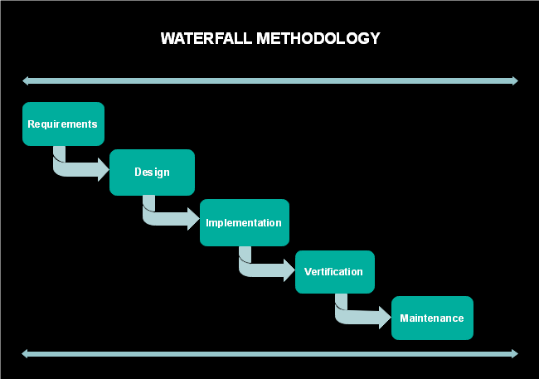

**Some advantage of Watterfall Methods are:**

* Simple and easy to understand .
* The Phases are clearly defined.
* Works well for small projects and requirements.

**Testing type**

**Black Box testing:** Black box testing is a software testing technique where the tester doesn't have any knowledge of the internal structure or workings of the software.Instead, they focus on testing the functionality of the software based on its specified requirements and behavior.

**Why We use blackbox testing :** We test user experience and functionality here , we don't need to know about what is happening behind or programming issues. So we choose black box testing.Black box testing is often preferred over white box testing due to its focus on user experience and functional requirements. It doesn't require knowledge of the internal code, making it accessible to testers without programming expertise. Black box testing is also effective in identifying defects early in the development process, ensuring the software meets user expectations and business needs.

**Objectives:** To check user experience by searching and sorting random items. To implement the test we choose the waterfall Method , for user experience I use black box testing. I demonstrate a case study regarding positive and negative scenarios. By using selenium and google webdriver i simulate automation testing.

<https://demo.evershop.io/search?keyword=Nike+react+phantom+run+flyknit+2>

Get method